Remembering IC-B
I’m sure many of us have fond memories of time spent on the water or in conversations with Ian Castell-Brown. With all the recreational paddles, training paddles and competitions he was involved in, he served as an inspiration to many of us.

I first met Ian Castell-Brown around the end of 2003 when he was involved in organising a group who regularly paddled on a number of local waterways in the Eurobodalla. Since then I have paddled behind, beside, occasionally ahead of, or with Ian around one thousand times. Almost every Tuesday for about a decade we enjoyed a social paddle on the Tomago River. For a number of years we took part in fairly serious Saturday training sessions at Nelligen and at Tomakin. Ian regularly joined a group of local paddlers for a social paddle on Tuross Lake every Friday and on other local waterways on Sundays. He spent a lot of time on the water.

He was always a fiercely determined paddler and in spite of being seven years his junior, for a number of years I found it was all I could do to match his pace. There were so many examples of how much of his life was devoted to paddling. When he visited his daughter in Canada, he realised that he was doing so much paddling there that it made economic sense to buy a kayak and leave it in Canada rather than to keep hiring one. One of the stories he told after returning from one trip to Canada was about paddling in fog for about six hours, depending on a compass for direction and arriving just where he should have been at the end of that time.

Over a few years, he paddled all of the coast between the Eurobodalla and the Victorian border, usually by himself and camping on the beach. He persuaded me to join him and a friend for a trip out to Montague Island; launching at Mystery Bay, circumnavigating the island, lunching in a little bay with seals diving under our kayaks and returning to our launching point. Our return trip was interrupted briefly as we paused to watch a couple of whales heading north.

A large part of the reason I became involved in the NSW Marathon Series is because I was inspired by the fact that Ian had been a regular competitor for some time and obviously enjoyed competing. Ian has been a regular participant in the NSW series for more than a decade. During that time he has also competed at numerous Australian Masters Games, World Masters Games, NSW Marathon Championships and National Marathon Championships. At most of those events, he paddled both single and double kayaks.

In 2016 I joined him in his TK2 at the National Marathon Championships in Qld where we took out the gold medal. Since then we have paddled together at several NSW and National Marathon Championships. At the Australian Masters Games in Tasmania, he teamed up with Ann Lloyd-Green to compete on Lake Barrington in the Mixed Double event. As usual Ian had to drop down a couple of age divisions since paddling partners his own age are hard to find.

Just last month Ian and I took part in a virtual race organised as part of the Far South Coast Winter Ski Series. He and I paddled our K1s on the Moruya River. As usual Ian took off at a pace that I found hard to match, but eventually he tired a little and he finished a few minutes behind me. At that stage there was no reason the think that Ian would ever stop paddling. So I was surprised to hear when I asked if he wanted me to join him in his TK2 for an international 10km virtual race in a couple of week’s time, that he would have been interested, but had been admitted to hospital that day.

It always seemed that nothing could stop Ian paddling. A couple of years ago he and I were paddling his TK2 at Nelligen in one of the BGCC South Coast races. A short distance into the race, it became obvious that Ian was struggling but he seemed to recover and as we completed the first lap, I asked if he wanted to stop. He insisted that he was keen to do the second lap. It was only afterwards that we learned that he had had a heart attack on the water and two days later he had a stent fitted. Apparently a heart attack was enough to slow him down, but not stop him.
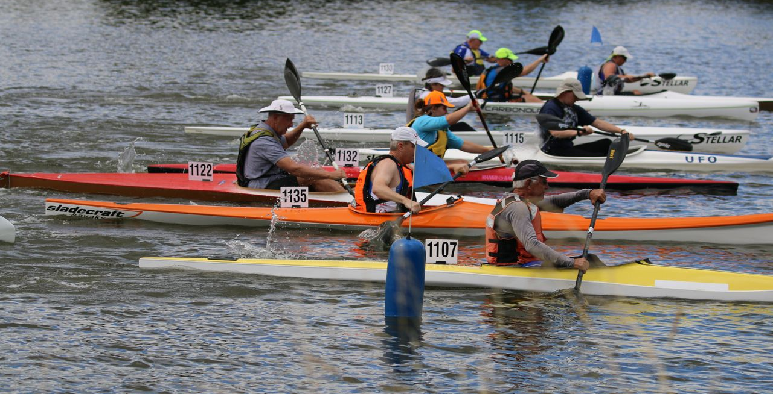
Ian lining up to start a NSW Marathon Series race against competitors who are mostly about half his age.

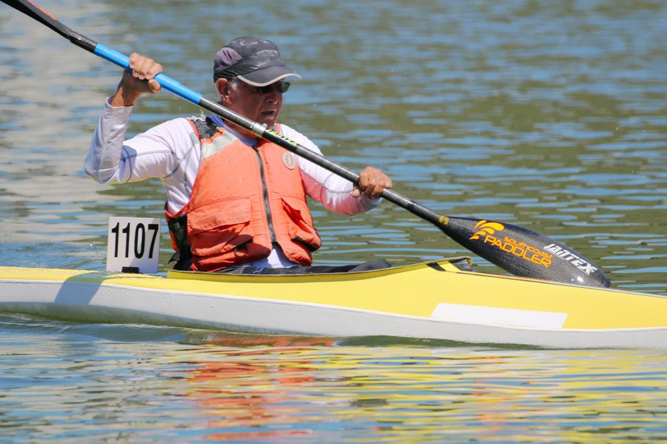
Ian competing in the NSW Marathon Series.

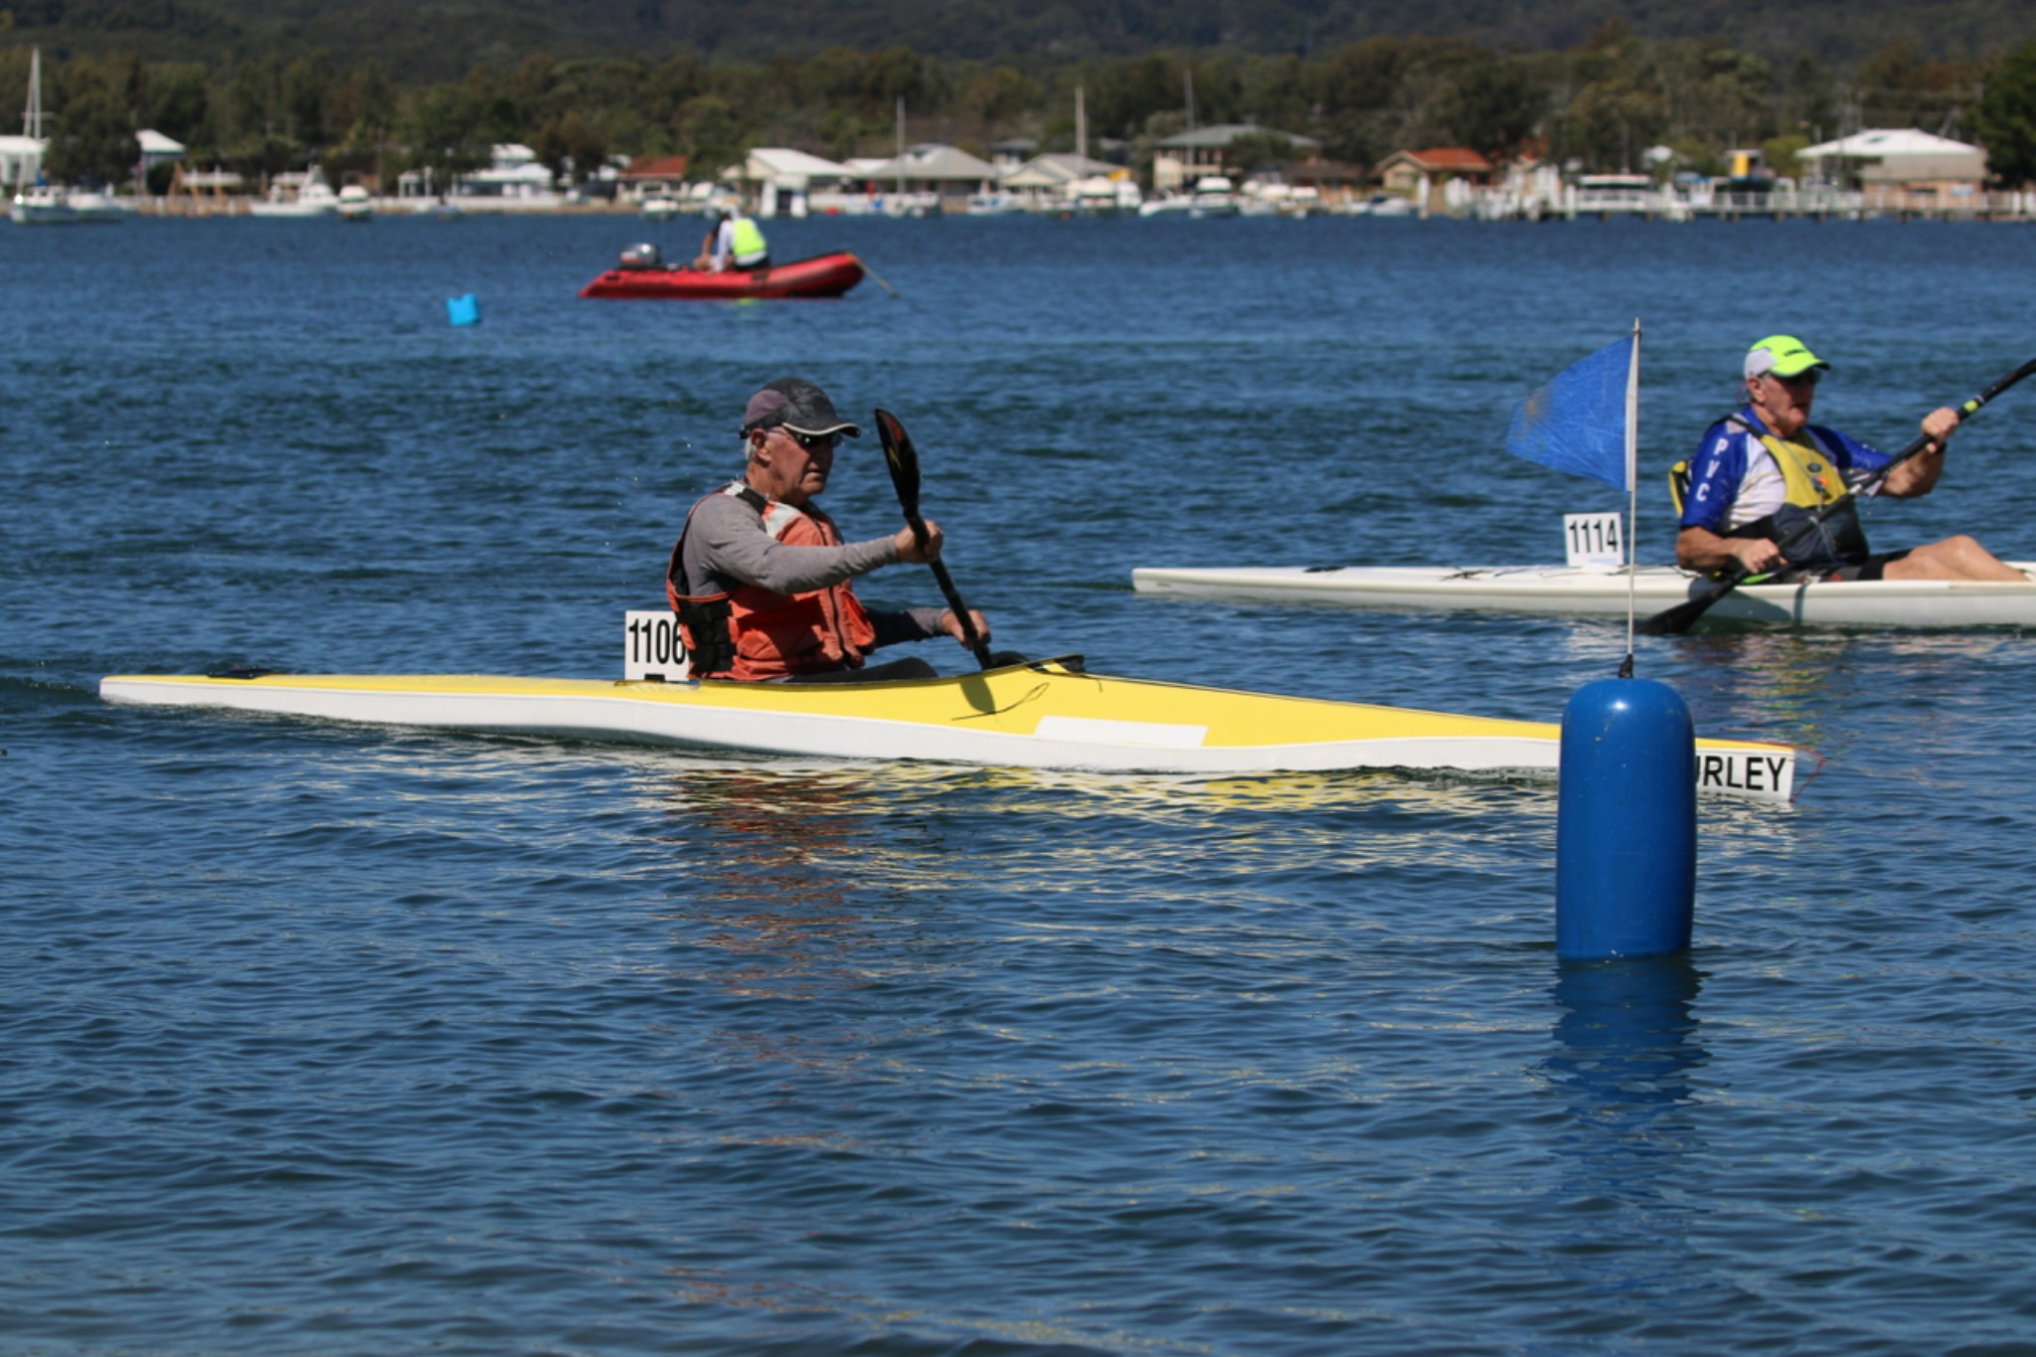
Ian looking quite relaxed crossing the line at Davistown in a Marathon Series race when many paddlers struggled in the conditions.

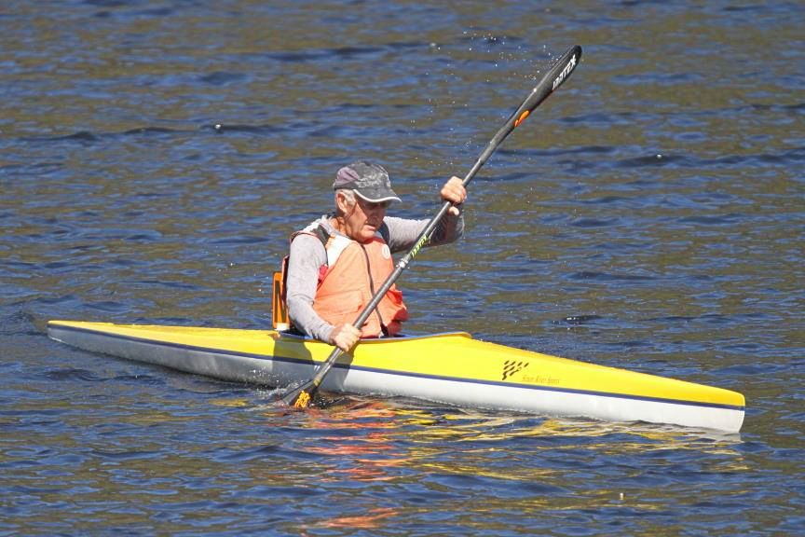
On Lake Barrington during the Australian Masters Games in Tasmania in 2017.

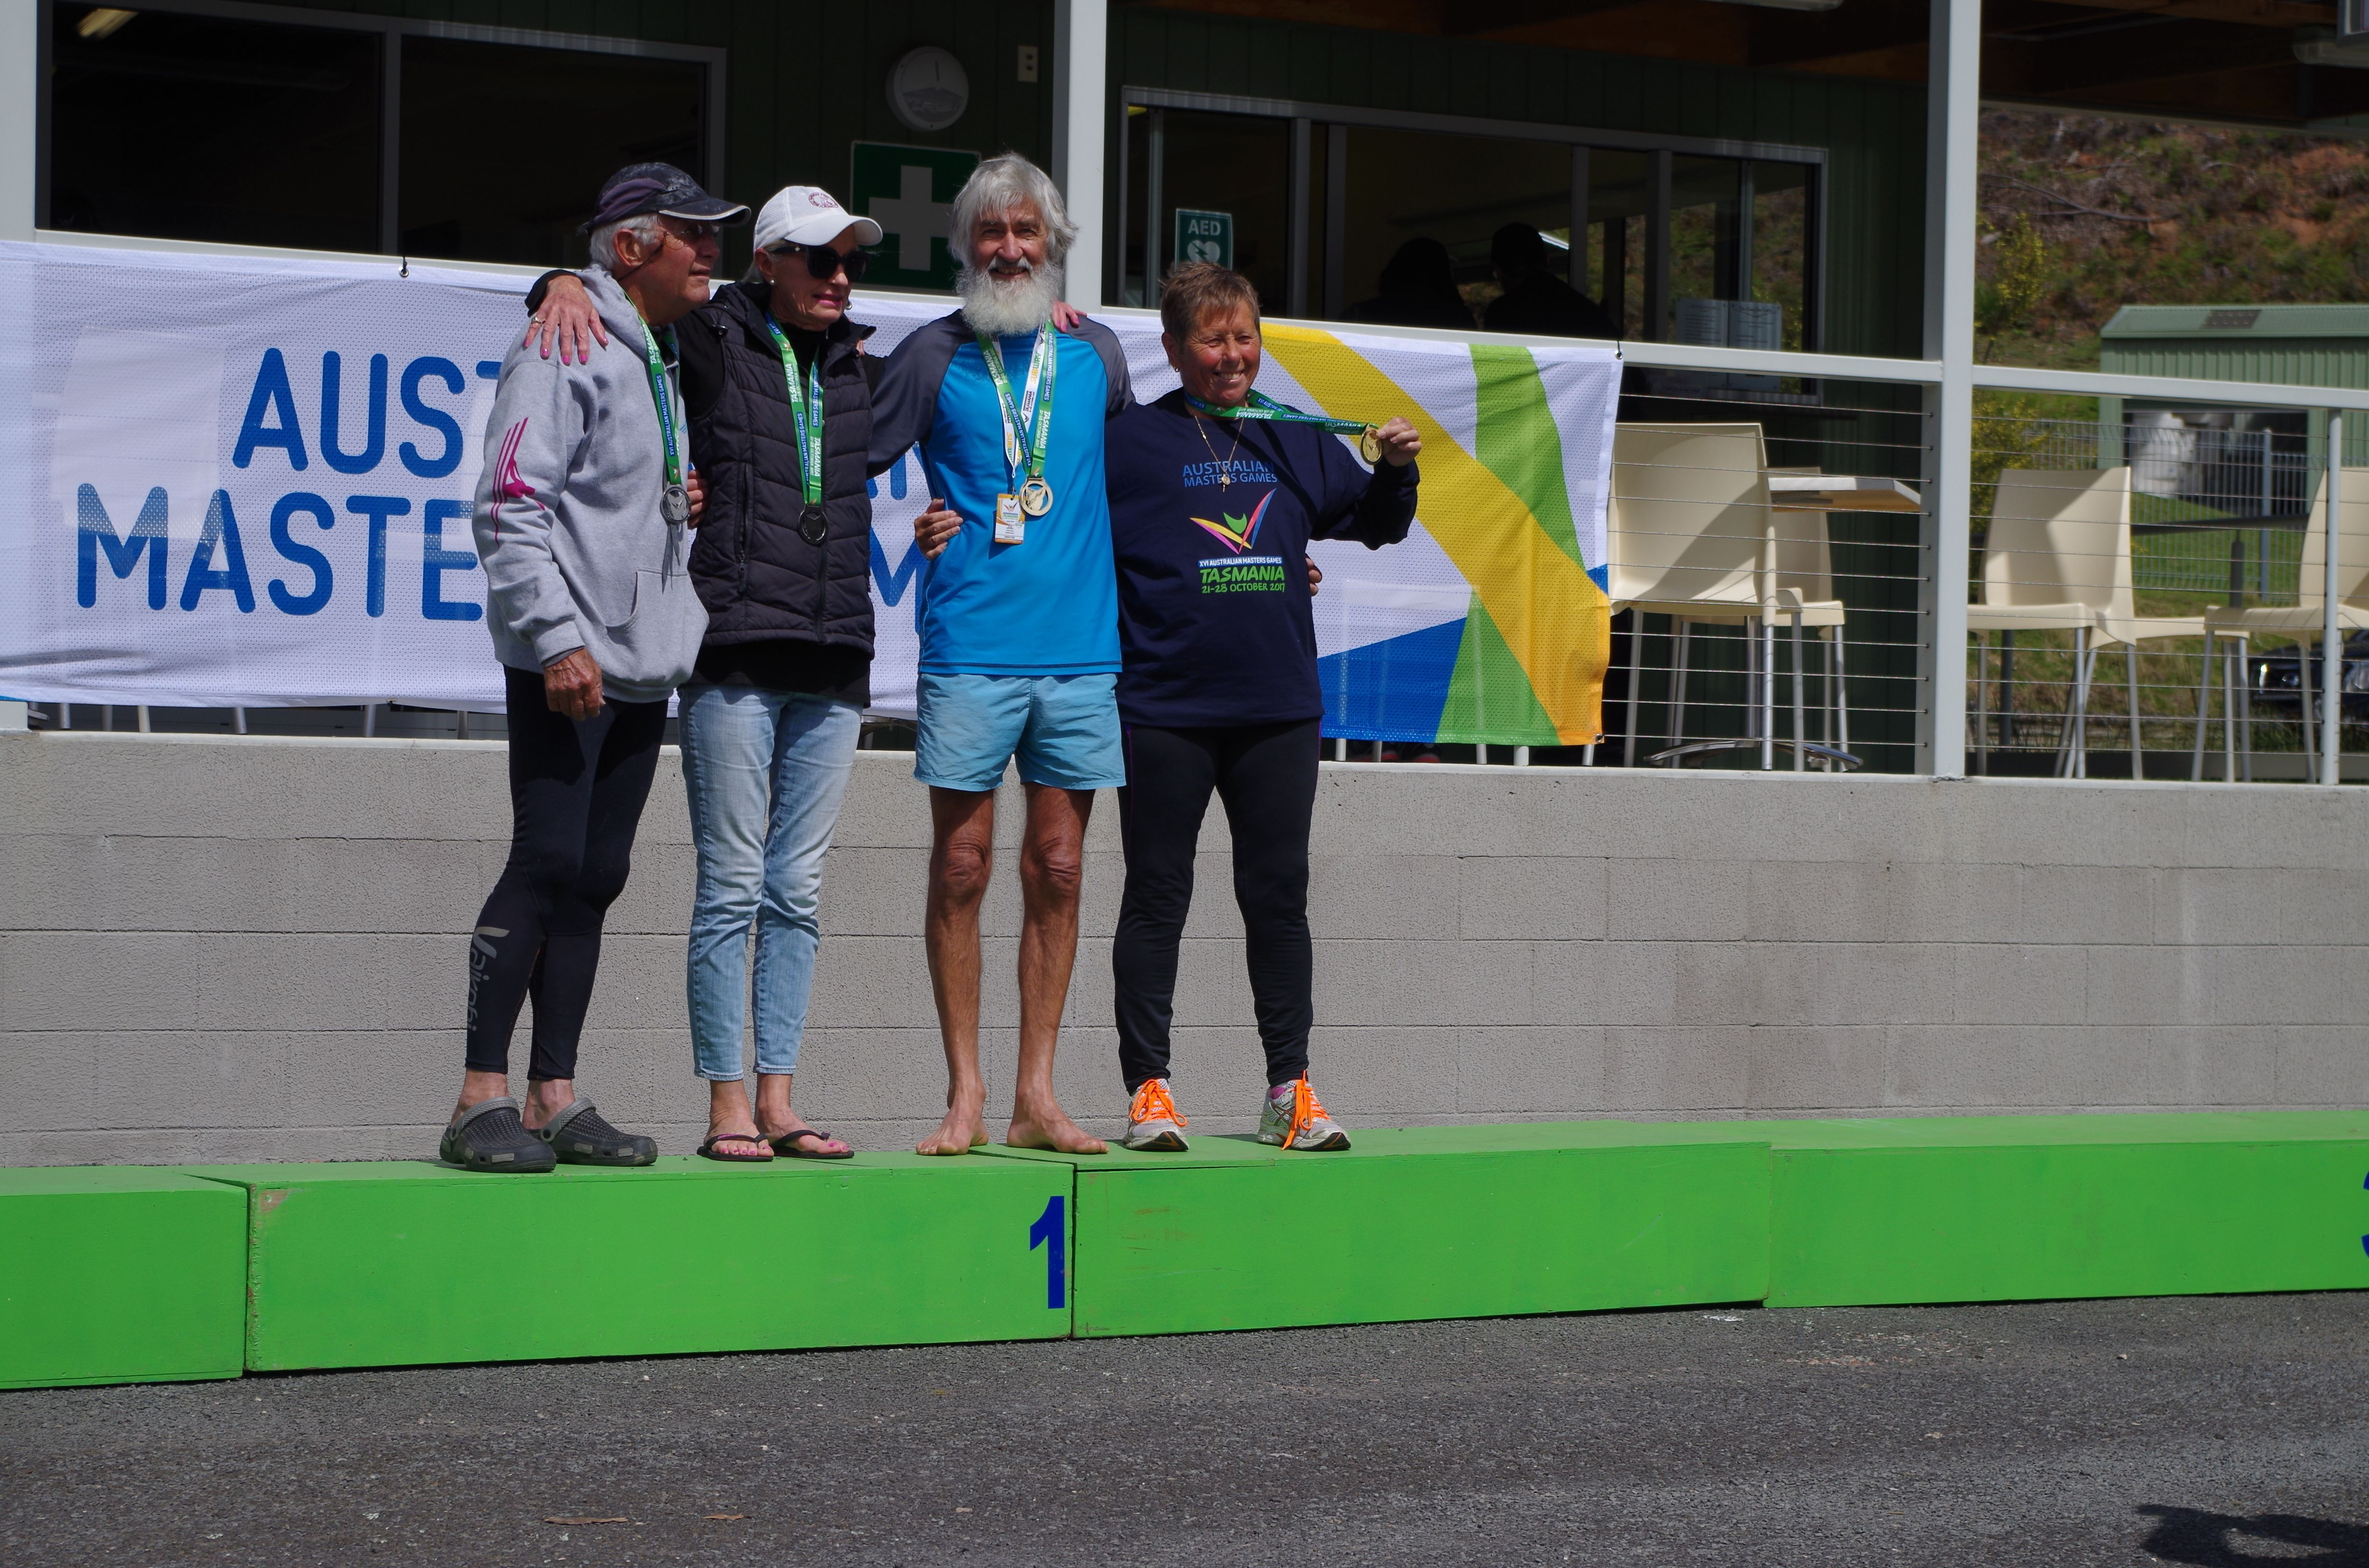
Silver medal with Ann Lloyd-Green at Australian Masters Games in Tasmania in 2017.

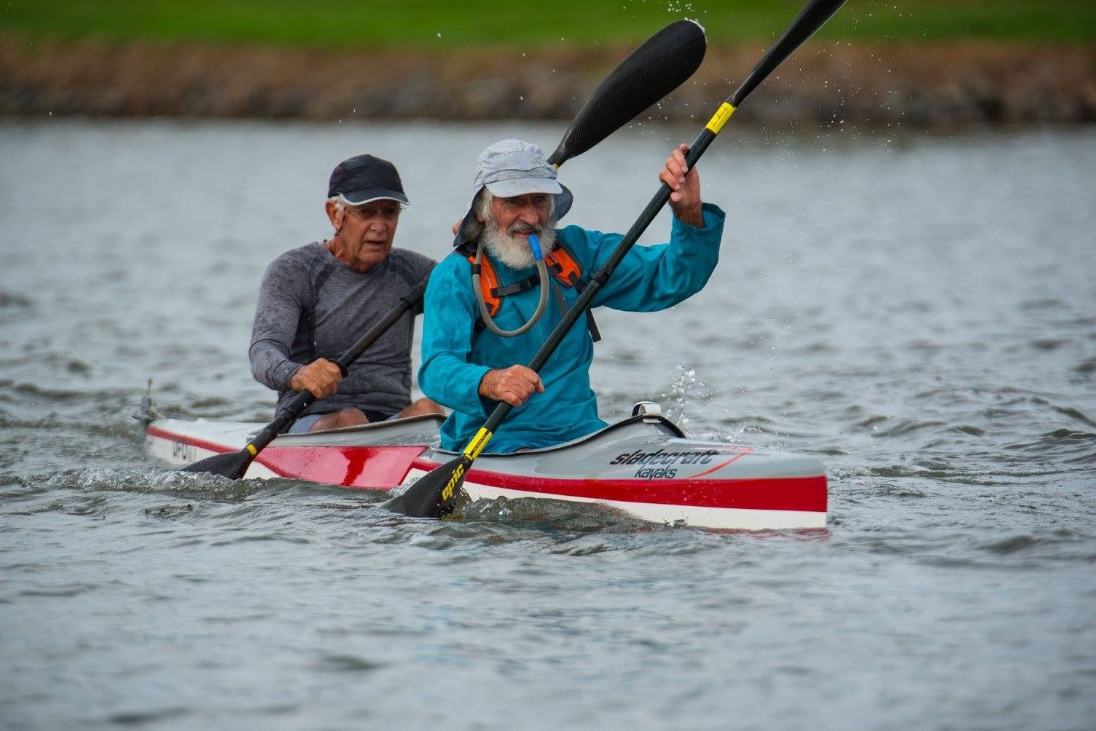
Ian and I at the National Marathon Championships in Queensland in 2016.

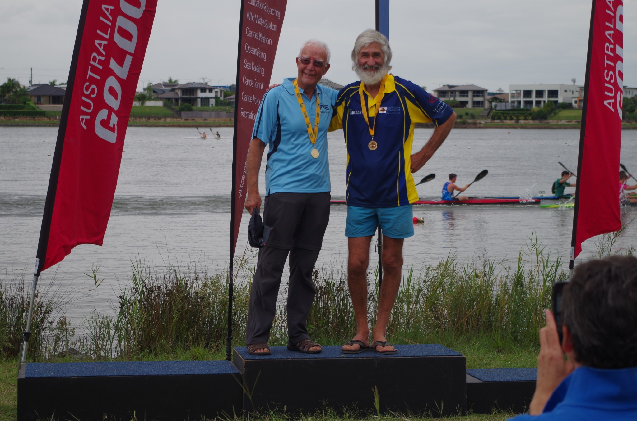
Gold medal at the 2016 National Marathon Championships in Qld.

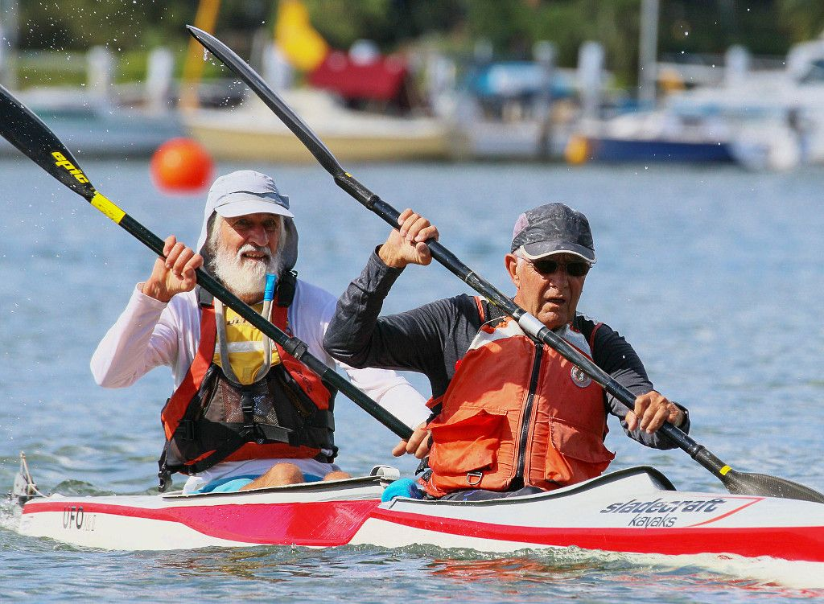
NSW Marathon Series Doubles Round at Lane Cove. Having Ian steering in the front seat was a better arrangement because he always had firm ideas about the course we should take.
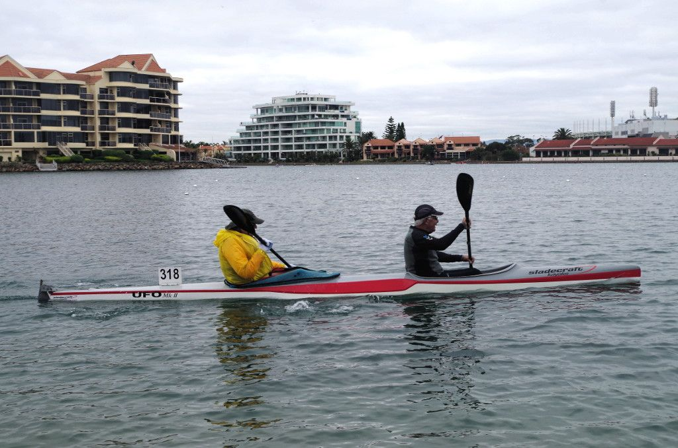
Ian competing at the Australian Masters Games on one of the rare occasions when he was able to find a partner who was older than himself.

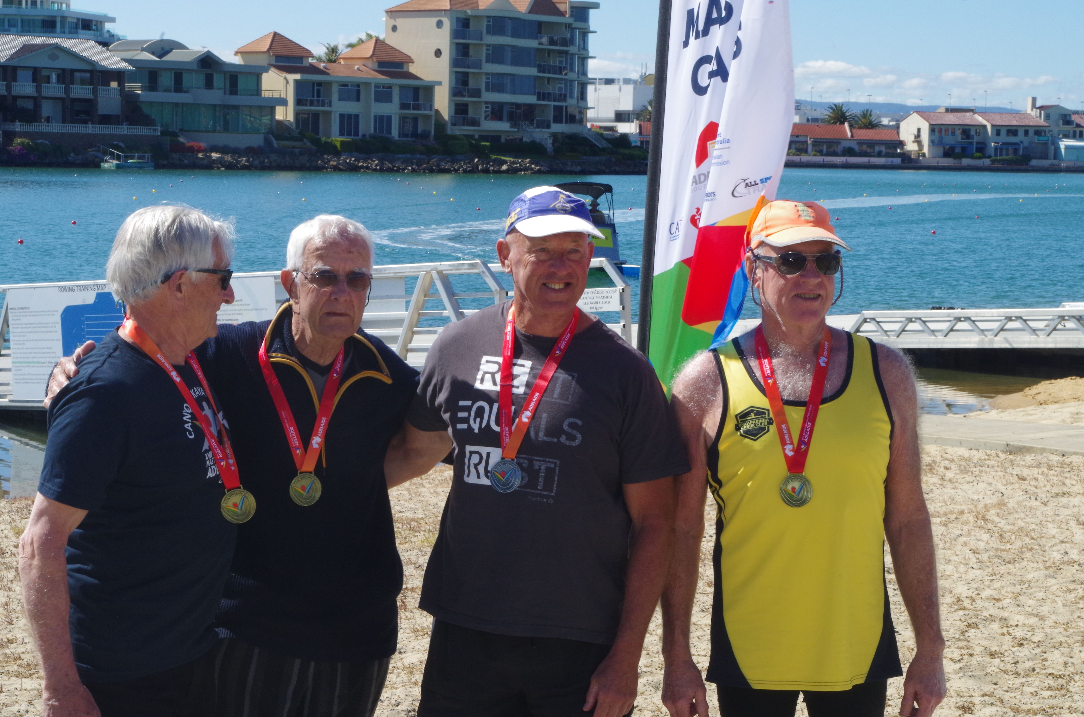
Another gold medal to add to Ian’s collection at the Australian Masters Games in Adelaide in 2019. Vet 80 double.

