Marathon Committee

Divisional Racing Rules – 2019

- The PaddleNSW Marathon Series comprises a number of ‘Divisional’ races run by the PaddleNSW Marathon Committee (‘the Committee’) and delivered by PaddleNSW affiliated clubs throughout NSW.
- The objective of the PaddleNSW Marathon Series is to provide a program of races for paddlers in ‘Time Divisions’ that match their paddling capabilities, and provide opportunities for, and recognize improvement in, paddler proficiency.
- The PaddleNSW Marathon Series allows paddlers of all age groups, to paddle boats of any class, and is based primarily on paddlers’ abilities to paddle a range of distances within certain time periods or brackets.
- The PaddleNSW Marathon Series is also seen as a development ground for paddlers wanting to compete at State, National and International levels, and aims to provide an opportunity for such development.
Race Distances
- Race Distances will be as follows:
  - Long Course (7 divisions) = 20 km (with portages where possible)
  - Short Course (4 divisions) = 10 km
  - Division 8 = 15 km
  - Division 13 = 5 km
- The 20km course will officially be known as the ‘Long Course’ and the 10km course will officially be known as the ‘Short Course’. Both are considered full competitive events.
- The 5km and 15km distances are available to any paddler as ‘bridging’ distances.
- Host clubs must ensure their course layouts are accurate and no shorter than the required 20km, 15km, 10km & 5km distances.
- Promotion will not take place automatically from shorter courses to longer courses.
- Paddlers seeking promotion to the longer distances will need to meet pre-qualification times as follows:
- Moving from 5km (Division 13) to 10km (Division 12) must be able to complete 5km in less than 40 minutes.
- Moving from 10km (Divisions 9-12) to 15km (Div 8) must be able to complete 10km in less than 1hr:10 minutes.
- Moving from 15km (Division 8) to 20km (Div 7) must be able to complete 15km in less than 1hr:45 minutes.
- Paddlers promoted into Division 1 will be assessed by the Committee and a Panel of Division 1 paddlers to determine how many, if any, portages they are required to complete in the first Division 1 race. Reviews will be conducted after each race, and paddlers will be advised of any change to portage requirements before the start of their next race. This is an initiative to help bridge the recognized gap between Divisions 1 and 2, and to assist paddlers to remain competitive in the transition. Paddlers who do not complete a portage must not take any personal advantage, or cause other paddlers any disadvantage, by doing so.
Divisions
- There will be 13 Divisions, each based on speed/time brackets, but not on boat type, or paddlers’ age/gender.
Division | Distance | Time to paddle | Approximate Speed | Promotion / Relegation %
1 | 20km + Portages | <1:40 | (>12kph) | 3%
2 | 20km | 1:40~1:45 | (11.5-12kph) | 3%
3 | 20km | 1:45~1:50 | (11-11.5kph) | 3%
4 | 20km | 1:50~1:55 | (10.5-11kph) | 3%
5 | 20km | 1:55~2:00 | (10-10.5kph) | 3%
6 | 20km | 2:00~2:10 | (9.5-10kph) | 5%
7 | 20km | 2:10~2:30 | (<9.5kph) | 8%
8 | 15km | 1:15~1:45 | (8.5-12kph) | NA
9  10  11  12 | 10km  10km  10km  10km | < 1:00  1:00~1:04  1:04~1:08  >1:08 | (>10kph)  (9.4~10kph)  (8.8~9.4kph  (<8.8kph) | 4%  4%  4%  4%
13 | 5 km | 00:32~00:45 | (<9.4kph) | NA
(Note that speeds are approximate only)
(Portaging is mandatory for Division 1, and optional for other divisions, where courses allow for it)

Initial Division Ranking
- Paddlers who are new to the series, and/or paddlers who have not competed in a PaddleNSW Marathon Series in the previous two (2) years, shall nominate themselves in the Division that they believe is most appropriate to their capabilities, and will use their first race as a ‘Ranking’ race (unless rules 18 or 19 apply), to confirm the most appropriate Division for future races.
- New Doubles Team entries (any combination of paddlers who have not paddled together in a PaddleNSW Marathon Series event within the previous two years) must also enter their first race as a ‘Ranking’ race (unless rules 18 or 19 apply), in a Division they believe most suited to their capabilities, but at a minimum, must compete in at least the next higher Division of the highest ranked individual paddler.
- Paddlers who have participated in the “PaddleNSW Marathon” series within the past two years will be allocated to the Division determined by the result of their last event.
- Regular doubles paddlers who elect to paddle a single, have the following options:
- If they have paddled in a Single within the previous two years they can enter the Division determined by the result of their last event in a Single.
- If they have NOT paddled in a Single in the previous two years they can either;
    - Enter in one (1) division lower than the Division determined by the result of their last event in a Double.
    - Enter in an appropriate Division as a ‘Ranking’ race (unless rule 18 applies).
- The Committee may request that any Paddler or Doubles Team review their entry and select another Division, in the interests of all paddlers.
- Paddlers/Teams entering in Divisions 1, 8, 9 and 13 shall not be required to paddle a ‘Ranking’ race.
- New double combinations entering in the ‘Doubles Round’ shall not be required to paddle a ‘Ranking’ race.
- Personal Points and Club Points will not be awarded to Paddlers/Doubles Teams in their ‘Ranking’ race, or to Paddlers/Doubles Teams who do not paddle in their correct or allocated Division.
Re-ranking: Promotion and Relegation
- The Committee reserves the right to review results and rankings and apply Promotions and Relegations after each race. The Committee, at its discretion, will make appropriate allowances for other influencing factors when reviewing results and considering re-rankings.
- Appeals against re-ranking must be made, in writing, to the PaddleNSW Marathon Committee, (marathon@paddlensw.org.au) prior to the next race, after results/re-rankings are published.
Promotion – updated rules for 2019
- Promotions will be determined by the Committee and will be based on comparison to a BENCHMARK time for the Division in each event.
- The BENCHMARK time will be recalculated after each race and will be used to determine any promotions based on that race. This allows for the variability of course lengths and conditions (ie ‘fast’ and ‘slow’ courses).
- The BENCHMARK time for each Division will be the MEDIAN time of finishing competitors in that Division. The race system includes a function that automatically calculates the MEDIAN and this is visible on the public results. This will be the measure of ‘median’ used.
- Where the use of the MEDIAN time would, in opinion of the Committee, produce an outcome that is inconsistent with the intent of the benchmarking system (ie to promote fair racing), the Committee may apply its judgement to make an alternate decision on promotion in accordance with Rule 21.
- Promotions, when determined, are mandatory. Paddlers must enter subsequent races in the higher division.
- Promotion rules do not apply to Divisions 1, 8, 9 & 13.
- Paddlers/Teams in Divisions 2-5 whose finishing time is faster than the benchmark time for their Division by 3% or more will be re-ranked to an appropriate higher Division.
- Paddlers/Teams in Division 6 whose finishing time is faster than the benchmark time for their Division by 5% or more will be re-ranked to an appropriate higher Division.
- Paddlers/Teams in Division 7 whose finishing time is faster than the benchmark time for their Division by 8% or more will be re-ranked to an appropriate higher Division.
- Paddlers/Teams in Divisions 10, 11 & 12 whose finishing time is faster than the benchmark time for their Division by 4% or more will be re-ranked to an appropriate higher Division.
Relegation – updated rules for 2019
- Relegations will be determined by the Committee and will be based on comparison to a BENCHMARK time for the Division in each event.
- The BENCHMARK time will be recalculated after each race and will be used to determine any promotions based on that race. This allows for the variability of course lengths and conditions (ie ‘fast’ and ‘slow’ courses).
- The BENCHMARK time for each Division will be the MEDIAN time of finishing competitors in that Division. The race system includes a function that automatically calculates the MEDIAN and this is visible on the public results. This will be the measure of ‘median’ used.
- Where the use of the MEDIAN time would, in opinion of the Committee, produce an outcome that is inconsistent with the intent of the benchmarking system (ie to promote fair racing), the Committee may apply its judgement to make and alternate decision on relegation in accordance with Rule 21.
- Paddlers/Teams in Divisions 1-6 and 9-11, whose finishing time is slower than their Division benchmark time by the percentages identified in the Promotion policy (and the Promotion/Relegation % column of the division table) for two (2) consecutive races, will be recommended for relegation to an appropriate lower Division.
- Relegations, when determined, are RECOMMENDATIONS ONLY. Paddlers MAY enter subsequent races in the lower division as determined by the Committee or may choose to continue racing in the higher Division.
- Relegation rules do not apply to Divisions 7, 8, 12 & 13, however the Committee reserve the right to relegate paddlers who finish in a slower time than the upper limit in Divisions 7 & 8 into a Division with a shorter distance.
Starting order
- Starting order shall be: Div 7, Div 6, Div 1, Div 2, Div 3, Div 4, Div 5, Div 8, Div 9, Div 10, Div 11, Div 12 & Div 13.
- Where possible, each division shall have its own start, at intervals determined by the Starter, taking into consideration issues such as course layout, weather conditions on the day, and others that influence the running and/or safety of the race.
- Typically, Division 7 will start at -15:00 minutes, Division 6 will start at -10:00, Division 1 will start at 0:00, and each Division thereafter at intervals of two (2) minutes or as determined for the course.
- Any or all starts may be combined (depending on numbers) at the discretion of the Committee. Any amalgamations will be announced at the race briefing.
- Starting order may be changed at the discretion of the Committee or the host club. Any change to the starting order will be announced at the race briefing.
Individual Points
- Points shall be awarded to Boat/Team Entries as follows :
- Every Boat/Team Entry’s race time shall be ranked fastest to slowest in each Division.
- The fastest boats in each division will receive 50 points.
- The second fastest boats in each division will receive 49 points.
- Third fastest boats in each division will receive 48 points etc.
- A Boat/Team Entry shall be defined as follows:
- For a Single Boat entry – the name of the single Paddler on that entry
- For a Double Boat/Team entry – the combination of the two Paddlers names on that entry.
- Every race (except a Ranking Race) shall contribute to a Boat/Team Entry’s total Individual point score, with the lowest scoring races being dropped, and a maximum of the seven (7) highest scoring races counting towards the final end of season total score.
- In the case of Doubles entries, points will be awarded to the Boat/Team combination only, with the exception of the Doubles Round (see rule 55 b iii).
- If paddlers swap partners in Doubles during the course of the series the new combination will be treated as a new Boat/Team Entry, with points being accumulated separately from points already earned in a previous combination.
- Points cannot be carried up or down between the Divisions or Distances.
Points earned in a Division will count towards a paddler’s or team’s total for that Division only with a minimum of five (5) races required in any one Division to be eligible for a Divisional prize.
- Fixed Points Races
- Paddlers who enter and finish:
    - Designated Bonus Races (such as the Frank Harrison Memorial race in Albury or the Batemans Bay Paddle Challenge) will be awarded 46 Fixed Points.
    - State Championships in a Non-Championship race will be awarded 46 Fixed Points.
    - Doubles Round that is not a ‘State Championship’ in a double will be awarded 46 Fixed Points to each paddler as a single (as well as the usual points awarded as a double based on the finishing position in the Division).
- These races can be counted as one of the seven (7) highest scoring races in a Boat/Team Entry’s End of Season total pointscore, but cannot count as one of the five (5) races required in one Division for prize eligibility.
Club Points
- The two (2) highest placed boats from each Club, in each Division, shall earn points for their Club towards the Brian Norman Club Trophy. Points will be awarded based on finishing position within the Division, on the same scale as Individual points are awarded (50 points for first place, 49 for second, 48 for third, etc.). Where a Club is represented by more than 2 boats in any Division, only the two highest placed boats will earn points. Where a Club is represented by only one boat in any Division, that boat will earn points based on final placing. (see example below)
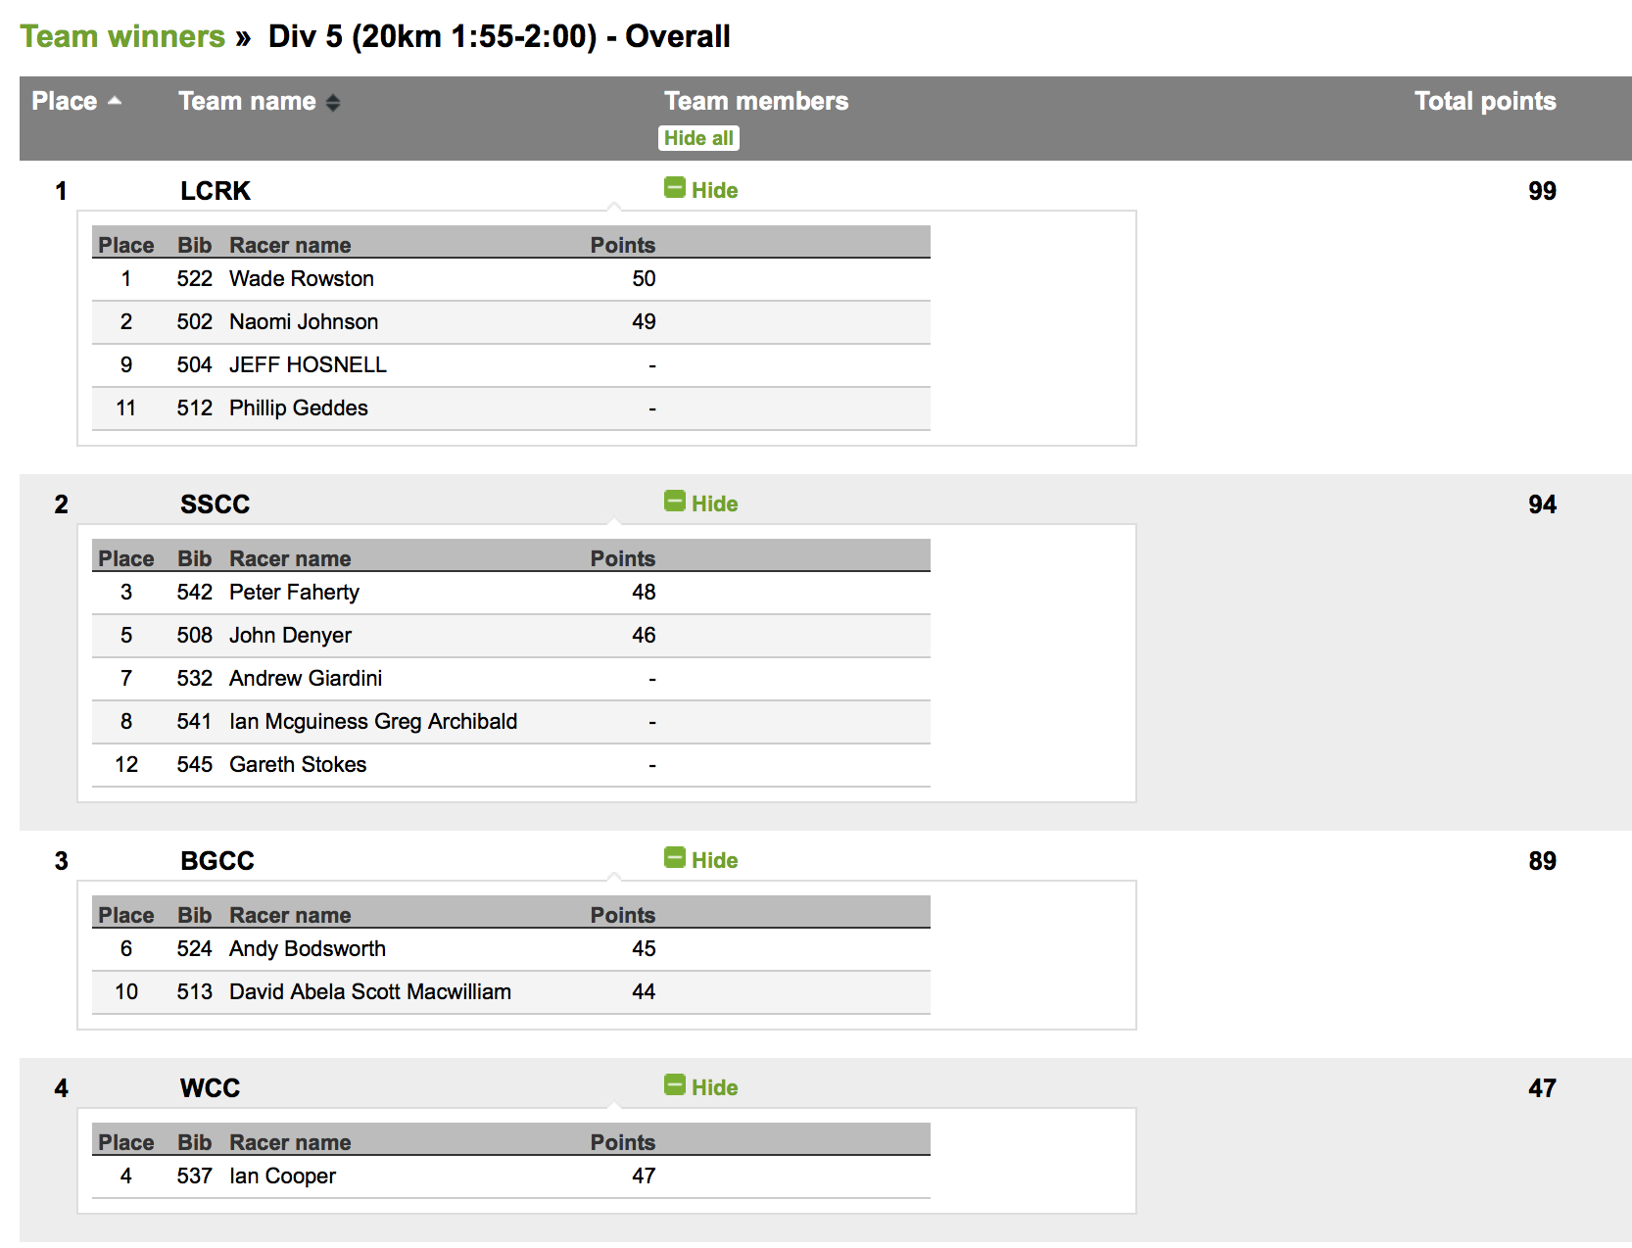
- Doubles paddlers from the same Club only receive one set of Club points. Doubles paddlers from different clubs must nominate one Club to receive any points.
- Bonus CLUB points – Portage Round
  - If an event is designated as a ‘Portage Round’, any paddler in any craft (not limited to ICF Class boats) may elect to voluntarily portage and earn fifty (50) additional Club Points (per boat) for their club if they complete all required portages. These Club points are in addition to any other points earned for the race.
  - Paddlers wanting to portage and earn additional Club points must complete tick the ‘Portage’ box on the online entry and complete ALL required portages.

- Bonus Club Points – Doubles Round
  - If any event is designated as a ‘Doubles Round’, paddlers who complete the event in any double craft will earn 50 Club Points per boat for their club – in addition to any normal placing points earned towards the Brian Norman Club Trophy.
ICF Class Points
- ICF Class boats (K1/K2/K4, C1/C2) in each Division shall also be able to earn points towards the ‘ICF Class Trophy’, sponsored by PaddleNSW, to be awarded to the Club with the highest number of ICF Class points at the end of the series.
- One ICF Class Point will be awarded to every ICF class boat that finishes in its Division.
- Skegged Masters boats are not currently recognized as ICF compliant, but will be accepted for the PaddleNSW Marathon series.
- Boat type must be specified on the online entry.
- Paddlers in other Divisions, may elect to Portage (where courses provide for it) and can earn one (1) additional ICF Class Point for their Club if they complete all required portages. This rule also applies to non-ICF craft who elect to portage.
- Bonus ICF points – Portage Round
  - If an event is designated as a ‘Portage Round’, any paddler in any craft (not limited to ICF Class boats) may elect to voluntarily portage and earn two (2) additional ICF Class Points for their club if they complete all required portages. These ICF Class points are in addition to ICF Class points earned for paddling an ICF Class boat.
- Paddlers wanting to portage and earn ICF Class Club points (in a standard race or Portage Round) must complete tick the ‘Portage’ box on the online entry and complete ALL required portages.
Prizes/Awards
- Prizes may be awarded at the end of the Season as follows:
- Highest points overall
- Top 3 highest points in each division
- Most improved paddlers
- Encouragement awards
- Outstanding Paddlers – single or doubles
- Veteran/Junior award
- 100% Participation medal
- Highest accumulated Club Points for the Brian Norman Club Trophy.
- Highest accumulated Club Points for the ICF Class Trophy
- To be eligible for prizes, a paddler MUST complete a minimum of seven (7) races during the Series.
- If an event is cancelled during the race, all participants who have started, will be awarded the maximum 50 points. No Club or ICF Class Points shall be awarded.
- If a race is cancelled before the event begins, no points will be awarded.
Conduct of State Championships – new rules from 2019
- The PaddleNSW State Marathon Championships for single craft and double craft will be conducted on separate days and as part of the regular marathon series.
- The State Championship races will be conducted with the same classes, genders and age groups as National Championships. The boat classes will be ‘ICF – Portage’, ‘ICF – Non-portage’ (including skis) and ‘Recreation’ (all other classes). Masters age groups will be in 10 year increments from age 35.
- Race distances will comparable to the distances at National Championships - rounded to the nearest 5km in most cases.
- ‘Non-Championship’ races will be offered over 20km, 15km, 10km and 5km distances to cater for paddlers who do not wish to race over the distance required for their age group or those who wish to race in a double at the singles championships or a single at the doubles championships.
- Paddlers in Championship races will be awarded individual/boat points on the same basis as in regular Division races – ie 50 points for winning their class, 49 for second etc. Points earned in the State Championships will be carried into the Division the paddler enters at their next race after the championships.
- Paddlers in Classes that require portaging at National Championships must complete all portages at State Championships to be eligible for a medal.
Doubles Round
- If a ‘Doubles Round’ is also a ‘State Championship’, the races will be conducted in similar format to the State Singles Championship. Refer to Rules 64 -69.
  - Points will be awarded for placing in Classes in Championship races, and 46 Fixed Points in Non-Championship races, and those points can be carried back into the Division pointscore.
  - Regular doubles paddlers will be able to carry points earned in a State Championship race back into their regular racing Division.
  - Paddlers who normally race in single boats will EACH carry their points from the Doubles Championship race placing back into their individual Division pointscore.
- If a ‘Doubles Round’ is not a ‘State Championship’ (ie a Doubles Round conducted in regular Divisional racing format), the following rules apply:
  - Paddlers who normally race in single boats will also earn 46 points towards their individual Division pointscore in their regular single Division (which can count as one of the best 7 races).
  - Regular double combinations will be eligible for Division points in the normal manner.
  - Worked example: A new combination of paddlers (who normally race as single paddler) enter the Doubles Round, and win their race. They will each earn 46 points towards their regular single Division pointscore and they will earn 100 club points (50 for the win and 50 bonus points for competing).
Lifejackets – (PFD’s)
- If applicable legislation requires that paddlers in a single craft must wear a lifejacket (ie no lifejacket exemption in place for the event), the Committee will apply that as rule to ALL paddlers whether they are in single or double craft.
- For the avoidance of doubt, every paddler must have a lifejacket available for use on the day.
- There may be some instances where lifejackets may not be required, and the Race Director and/or the Committee will advise if this becomes the case for any specific event and will advise if there are other rules that paddlers must follow.
- Regardless of any other rule, ALL U14 paddlers must wear lifejackets.
- Junior Ages shall be interpreted as per Paddle Australia Rules and, as such, will be determined as at 1st January in the year of competition.
- Juniors under 10 years of age are also required to be accompanied by a suitably experienced and capable on-water chaperon.
- All lifejackets must comply with legal requirements.
- Inflatable lifejackets are not permitted.
Disqualification
- All competitors must respect the spirit of fair play and non-violence and behave in accordance with the rules of good sportsmanship.
- Any competitor who attempts to win a race by any other than honorable means, or who breaks racing regulations will be disqualified for the duration of the race concerned, and may incur further penalty at the discretion of The Committee.
- Physical violence will result in immediate disqualification for the duration of the race, and referral to the Committee (and PaddleNSW if deemed appropriate) regarding disciplinary action and eligibility for future races. All participants should be aware that physical violence is also a matter for common/criminal law and will be dealt with accordingly, in addition to any action taken by the Committee or PaddleNSW.
Interpretation of Rules
- The intention of the above Rules is to provide a fair and enjoyable competitive environment for all paddlers. In situations not covered by the above Rules, reference shall be made to ICF Canoe Marathon Rules, or Paddle Australia Marathon Competition Rules and/or Bylaws, as appropriate. For any situation, which is not specifically addressed by ICF or Paddle Australia Rules, the decision of the PaddleNSW Marathon Committee shall remain final.
Code of Conduct
- PaddleNSW has adopted Paddle Australia’s Member Protection Policy. The policy contains a General Code of Conduct and additional requirements for athletes, officials, participants, volunteers, instructors, coaches, parents and spectators. Anyone attending a PaddleNSW Marathon Series event should be aware of his or her responsibilities within the Codes of Conduct.

Entry Fees
- The entry fees for each race in the 2019 PaddleNSW Marathon Series shall be as follows:
Individual/Team | Age | Early Bird | Standard | Day License for each paddler who is not a member of PaddleNSW
Individual | Under 18 | Free | $10 | $10
 | 18-24 | $20 | $30 | $15
 | 25-65 | $35 | $45 | $20
 | 66 and over | $30 | $40 | $20
Team | Doubles entry – U18 | Free | $20 | $10
 | Doubles entry – U25 | $40 | $60 | $15
 | Doubles entry – U66 | $70 | $90 | $20
 | Doubles entry – 66+ | $60 | $80 | $20
 | Doubles entry – Vet (66+)/Junior (U18) | $30 | $40 | $20
 | Doubles entry – Vet (66+)/U65 | $65 | $85 | $20

Paddlers requiring further information should direct any questions relating to PaddleNSW Marathon Series to marathon@paddlensw.org.au

